Connectors yani kisi external source s data la kr power BI m import krna

DATA MINING:
Data mining yani data s hidden patterns ko nikalna h and we can easily done it using power query editor in power BI. we can use different measures for it.

IMPORTING:
Same just like excel k ap ko import krna h chahy folder k zrye kr lo ya kisi bhi cheez k zrye , folder k afaida y ho ga k saari files akathi import ho jayn gi, then transform pr click kia and power query editor open ho gya and same interface as of excel as MS AXCEL bought power query editor form POWER BI.

MODULE: DATA TRANSFORMATION
Same NULL values vala bhi concert k hmy phly NULL valo ko replaca krna ho ga null m and then up ya down s fill kr dena h,, baaz dfa null values ko fill nhi bhi krty e.g: employee designation k agy kikha ho reports to and us column m likha ho yani is post valy log is ko report kryn gy, ab president k agy valy reports to empty ho, to hm fill nhi kryn gy because president n kisi ko report nhi krna,,, similarly, shipped date m kuch null values hn q k un null values pr status ya to cancelled h ya on hold h ya in process h yani abhi y order shipp hua hi nhi, to abhi hm isy fill nhi kryn gy because future m hm is s kuch nia table bna ksty jis m ho hi just vo dates jin ka status esa tha q k in orders pr pesa bhi hmy nhi mila

→ for merging 2 columns, select both columns and click on merge columns, and merging s phly white spaces check kr lena and for soing so select column then first m ja klr trim pr select kr lena (TRIM REMOVE WHITE SPACES FOR BOTH STARTING AND ENDING WHITE SPACES),, merge column skrty huy jis ko ap n phly select kia then ctrl kr k doosra column baad m select kia to merged column m bhi yhi order ay ga , yani jis order s columns ko select kia

→ right click on column and select remove duplicates for removing duplicated values, remove duplicates hm un columns m krty jin m unique values honi chahye and esa bhi hota h k unique values such as my CNIC repeat ho and is row k agy saary columns same CNIC vali row s different ho yani btaya y ja rha ho k is CNIC valy person n y 1 bar y order kia and then baad m dubara order kia oi or product, to is k loye hm CNIC valy m drop duplicates nhi kryn gy

because ke person 2 bar order kr skta , hm duplicates remove ktyn gy jab poori row same ho

Can click on custom columns in add column to get some little calculation, e.g: quantity each ko total orders s multiply krna h sales get krny k liye to hm in m s kisi column ko select kr k click on custom column and multiply kr sky dono ko

You can also add conditional column jis m ap conditional column pr click kro and conditions set kr de bilkul esy ui jesy if-else lgta h and else vali fill krna yaad rkhna

MERGE QUERIES bilkul esy hi h jesy JOINS hoty hn, kisi table pr click kro and merge queries m jao and vhan doosry valy us table ko select kro jis ka ki column ap n 1st table m lana h but merge krny ki condition common column h yani ap kisi common column ki base pr hi 2 tables ko merge kr skty ho,,, then jab merge ho jay ga to 1st table m TABLE name s ek column bny ga jis ko expand krna h by clicking button on right side of that column having name TABLE and un sab columns m s vo column select kr do jo ap is table m lana chahty ho

APPEND QUERIES tab use krty hn jab different tables hon and data same ho yani column name saary tables m same ho, e.g: kisi company ka data tha and 2002 ka data table 1 m tha and 2003 ka data table 2 m tha and in dono tables m column names same thy bs values different thi to hm in tables ko akatha krny k liye append queries lgay gy and jis table ko hm select kiye huy th and append queries pr click kia to usi tackle m abder hi doosra vala table append ho gya

if we want to append the two tables and if we have dates of both tables already in dates format, we can append two tables directly and easily, but if we have dates format of both in text (check from locale, insteda of seeing directly from column q k sometimes column dekhny pr date format hi show ho rha hota h but locale pr jany s format text hota h, yani agy kuch or peechy kuch, to sirf agy vala hi dekh kr final nhi kr lena h) then append these tables first and then chnage datatype from locale,,, if you chnage datatype first and then append, it will cause error of "We cannot parse the input provided as a Date value”,,,, locale m jany k liye column k saath vala jo datatype ka icon show ho rha hota (calender in case of date, 123 in case of numbers etc etc) us ko click kro and last option is locale,

DATE FORMATE: Kabhi kabhi hamein date is format mein di hoti hai: month/day/year (jaise: 12/26/2024), jo ke US format hai. Jab hum is column ko text ya kisi doosre format se date mein convert karte hain, toh error aata hai. Ye error is wajah se hota hai ke humare computer ka default date format day-month-year hota hai. Agar hum is date ko convert karte hain toh system isey is tarah likhne ki koshish karta hai: 12-26-2024, jisme month ki jagah 26 aa jata hai, jo ke logically galat hai. Kyun ke kisi bhi month mein 26 nahi ho sakta, is wajah se error aata hai.Is maslay ko solve karne ke liye:
- Aap date wale column ke naam par right-click karein.
- Change Type ko select karein.

- Phir Using Locale ko select karein.
- Uske baad type ko Date set kar ke, locale ko English (United States)
mein convert karein.
Is se Power BI ko samajh aa jayega ke yeh US format mein hai, jahan 26 day hai aur 12 month. Ab jab system isko humare local format ke mutabiq
day-month-year mein convert karega, toh yeh theek tarah se 26-12-2024 ban jayega.
You can also create TABLES in power BI, power query editor m hi home pr click on ENTER DATA and table create ho jay gi jis m data enter kr lo and click OK
PIVOTING AND UNPIVOTING OF DATA: this is also an interview question, yani jab hmary pas koi horizontal table hota h to hmy usy vertical table k ander convert krna hota h q k power query editor k bhi almost saary methods vertical table pr hi kam krty hn , to horizontal table ko vertical table m convert krny k liye hm pivoting and unpivting ka use krty hn, e.g: following is our horizontal table:

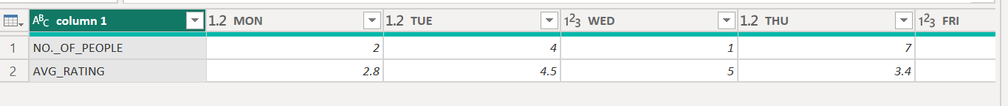

To sab s phly hm is column1 pr riht click kr k unpivot other columns pr click kry gy then hm 1st valy column or click kr k transform m click kryn gy pivote column pr and select kryn gy value ko from drop down because column1 k ander ka data VALUE m pra h, click OK and then you go!

Converstion of rows to columns called PIVOTING
Conversion of column to rows called UNPIVOTING

Ab number of people and average rating rows m h, hm n isy column m change krna h yani pivoting krni h and mon, tue, wed etc column hn and hmm n isy rows m change krna h to unpivoting krni h

Baaz oqat OK kr k ap ko vertical table mil to jata h but saary columns ki values 1 show hoti h to is k liye isi window m hi OK krny s phly advance option m ja k count ko hta kr don’t aggregate pr click krna h because sometimes vo column ki values ko count kr deta h, “don’t aggregate” kryn gy to shi output mily gi

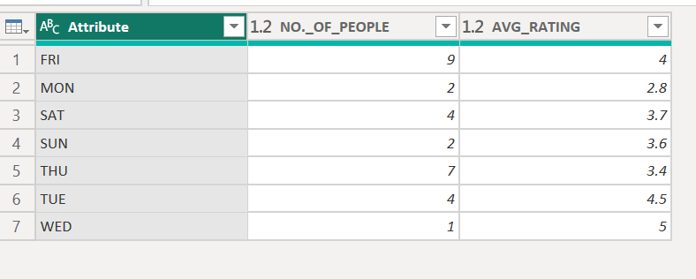

MOST EASY: means pivoting is conversion of rows to columns and unpivoting means conversion of columns to rows,, we use pivoting when we have repeating values in all the rows of a column(i.e only north and south in case of location) and we will convert these rows into different columns (one column for north and one for south),, to do this simply select that column that you wanna pivot and go to transaform tab and select pivot column and let power query apply aggregations automatically, if there are correct datatypes then aggregation will be applied correctly,,,,,, in case of unpivoting, such as we have 4 columns (JAN, FEB, MARCH, APRIL) and each containing number of sales, we want one column name MONTHS that contain all these months names and one columns SALES containing all data for each month, we will do unpivoting of these columns, we will select all columns other than these 4 columns (JAN, FEB, MARCH, APRIL) then right click on all others and select unpivot other columns, here you go!

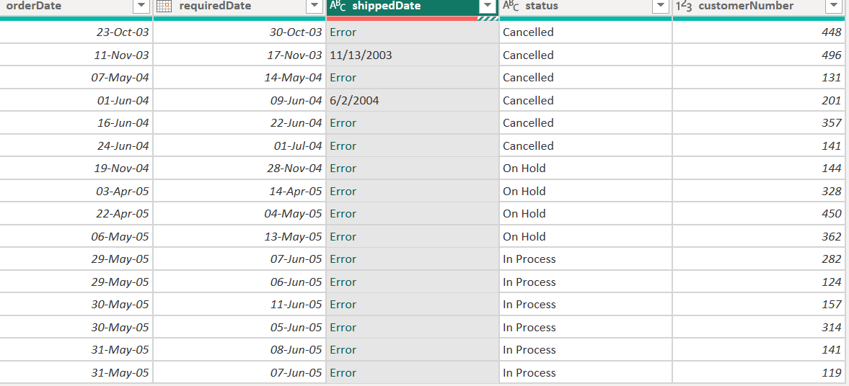
If you face error like below: right click kro is column ko and click on replace errors and null s replace kr k fill down ya fill up kr do

UNPIVOT COLUMNS KRNY KA MATLAB Y H K HM N IN COLUMNS KO KEY VALUE PAIRS K ANDER CONVERT KRNA H, UNPIVOT OTHER COLUMNS KA MATLAB Y HUA K IN KO CHOR KR BAKI SAB COLUMNS
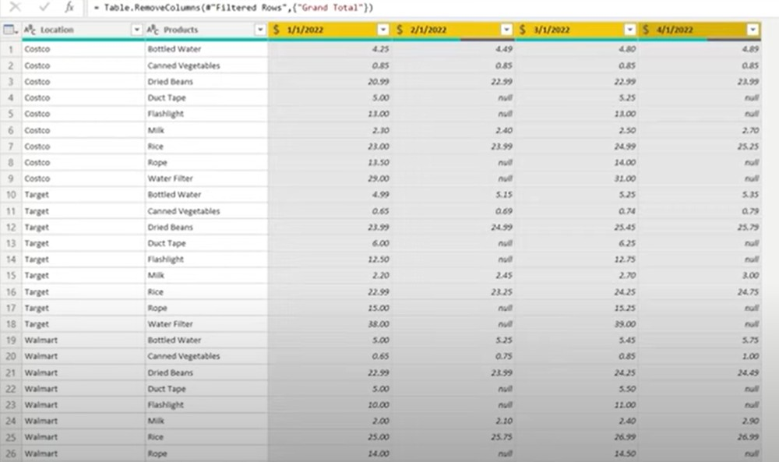
KO KEY VALUE PAIRS K ANDER CONVERT KR DO ,, e.g: agr is trah s table a gya or hmy is ko sahi show krna hua (consoder table in image below):

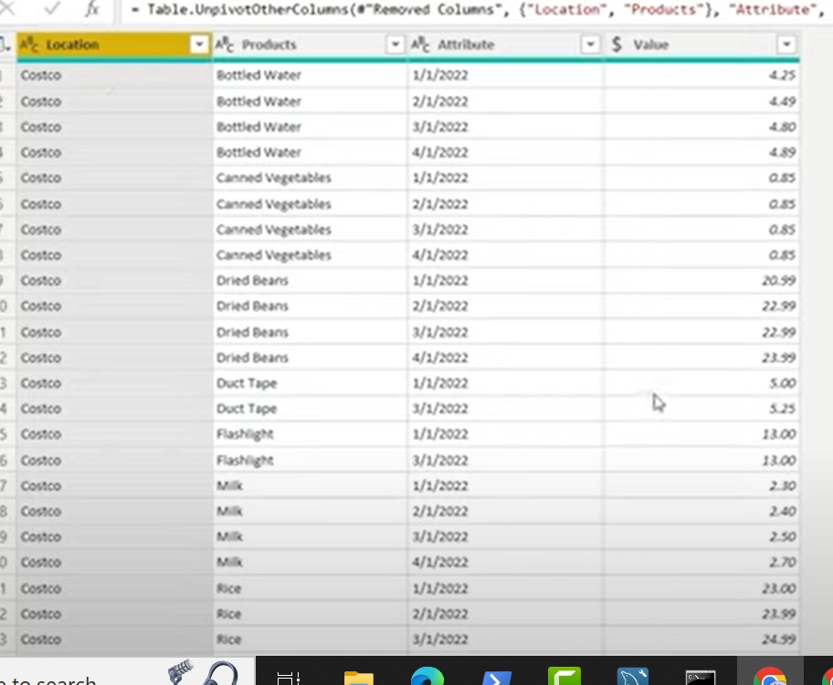
To hm in charo dates valy column ko pkry gy and UNPIVOT COLUMNS kry gy yani is s y key value pairs m convert ho jay ga, yani keys columns ka name ho gya yani dates ho gi and values in dates valy columns m data ho gya , and you will get modified column like this:

MODULE: DATA MODELING
Data modeling is a connection between different tables, such as order and products k table k ander connection build krna etc

Power query editor s close and save k baad jab model view m jao gy to tables k drmian power BI n khud hi connections build kiye hon gy on basis of common column but if khi khi connections nhi kiye huy to us table k column ko uthana and doosry table k usi column ko uper la kr chor dena h jo k un dono m common ho, yani table A and table B m common column is X then A m s X ko utha kr B k X k uoer chor do to conection build ho jay ga

These relationships have different cardinality such as 1 to many or many to many or many to 1 or 1 to 1 as well, based on concept of primary and foreign key, PK is unique identifier and FK is taking reference from PK , values in FK valy column m can be null (null FKs ka matlab h k y rows primary key valy column k saath connection nhi kr rhi h, and is s koi issue nhi ata, kuch rows k null hony ki vja s dono columns ka connections khatam nhi hota ) ya sirf vhi values hon gi jo PK valy column m hn and FK m values repeating ho skti hn of course. Products k table m product ID is primary key and orders k table m product ID is FK because products valy table m specific products ka hi data h and orders valy table m product ID of course repeat ho gi because vo product kafi dfa order hui either by same or different person, ZRURI NHI K PK VALY COLUMN KA JO NAME H FK VALY COLYUMN KA BHI VHI NAME HO, NAME DIFFERENT HO SKTY HN

E.g: ab employees and customers k table ko consider kryn to employee k table k ander EMP_NUM h and customer k table k ander vhi FK k tor pr h and here name of that column is customer_representative_employee_number, to hm in k drmian khud s connection build kryn gy, q k customer_representative_employee_number bhi to yhi bta rha k is customer ko deal krny valy employee ka number kia h
One to one: relation between 2 PKs
One to many: relation between PK and FK, which is most common
Many to many: relation between two FKs, this relation should not be exists

Cross filter directions: data model m jo jo connections hoty hn un sab m flow PK to FK ki trah hota h, this is cross filter direction, e.g: in customers and employees , there exist one to many relationship of employee number from employees to customer table , yani in table or in a chart you can calculate any thing from customer table based on employee table but customer k kisi column ki base pr employee table k kisi column ki information ko nhi lia ja skta yani agr ap rows m customer rkho and values m employee ka kuch rkho or chart bnany lgo to ghlt iformation mily gi, is s bachny k liye hm cross filter direction both sided bhi rkh skty hn , right click on connection, go to properties and cross_filter direction m both select kr do and you will get true output, vesy mostly one sided cross filter direction hi use hoti h

→ connection line pr double click krny s edit relationship vala page open hota h,

MODULE: DAX (Data Analysis Expression)

THIS IS VERY VERY IMPORTANT FOR INTERVIEWS, AGR INTERVIEW K LIYE APPEAR HONA H TO KUCH PRHA NA PRHA BUT DAX HR HAAL M PARH KR JANA

They are used for creating measures , creating new calculated columns and new tables as well, many hidden data patterns can be achieved using DAX.

Creating calculated columns using DAX functions: to is k liye hmy table view m hi ja kr home m ja kr calculated column pr click krna h, e.g: agr m chati hu k new column is base pr bny k agr isi table m stocks 500 s ziada hn to new

column jo k stock requirement k name s ho ga us m NO likha a jay and baki jga yani agr stock 500 s km hn to yes likha a jay yani hmy new stock required hn , is k liye write formula: stock_requirement = if(products[quantityInStock] < 500, "yes", "no")
Agr ek value chaty ho e.g: sum of total sales ya total footfall etc to is case m new column valy pr click nhi krna because we want just one value

FORMAT:
- This function is used to allow both text and number value in a column, agr hm y nhi likhty to error ata h, e.g: from a column having number of children as 0 ,1,2,3,4 and we wanna add new columns in which when 0 children write ‘NO CHILDREN’ and other values remain as it, then Column = IF(customers[num_children_at_home]=0,"NO Children",customers[num_children_at_home]) , this cause error because text and number cannot be in one column, we will use this: Column =
IF(
customers[num_children_at_home] = 0,
"NO Children",
FORMAT(customers[num_children_at_home], “0”) -- converts number to text
)
And saying consider 1,2,3, etc as text “1”, “2”, “3” etc etc
- FORMAT ALSO USED TO GET DIFFERENT FORMATS OF DATES, MONTHS, DAYS ETC ETC, LIKE USED IN SOME BELOW TOPICS OF THIS NOTES SUCH AS CALENTERAUTO()

TYPES OF DAX FUNCTIONS: phly number pr,
- calculated columns: where you calculate new columns in existing table
- Measures: to get singular values
- Time intelligence expressions
- Text basic functions
- Information functions
- Filter functions : e.g: sumifs, countifs etc
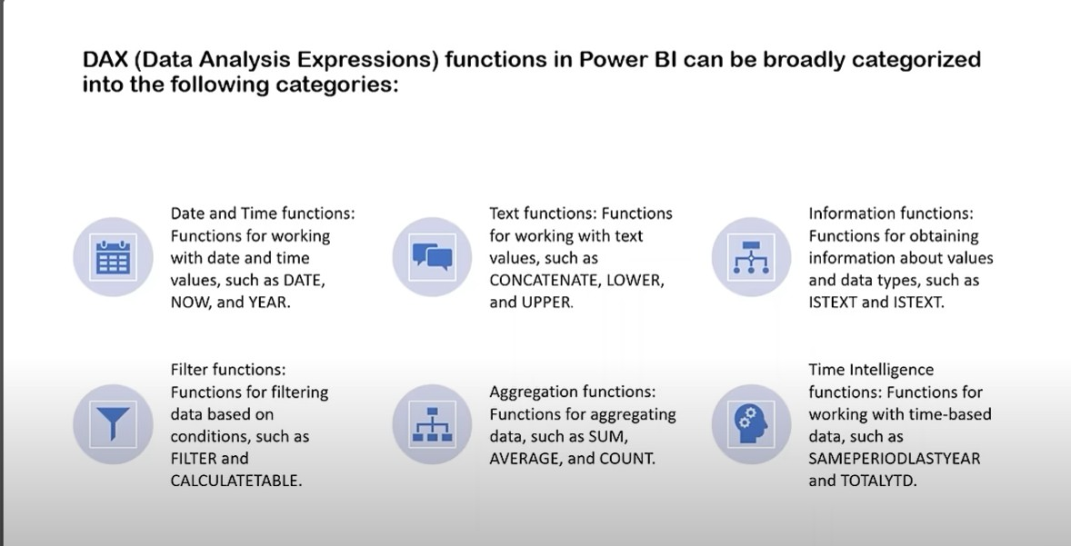
- Statistical functions

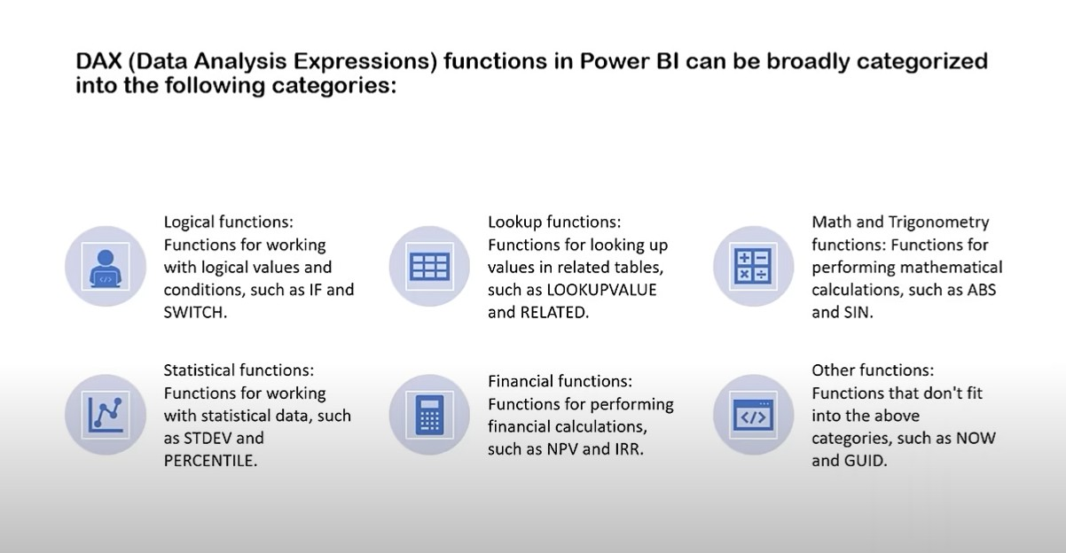

DATE AND TIME FUNCTIOSN IN DAX: to create a new column in a table that already has a column of full date, and we wanna extract year then click on new column then write formula: order_date = orders[orderDate].[Year]

→ if you want to get the difference between 2 dates , you can use datediff function, shipping_days_1 = abs(DATEDIFF(orders[shippedDate],
orders[orderDate],DAY)) , ab m n yhan last m DAY is liye likha q k mujy days ki base pr differenec chahye tha, e.g: agr dates esy h 21-sep-2023 and
24-sep-2023 to days ki base pr difference 24-21 yani 3 aya and agr months ki base pr difference dekho to 0 ay ga,, “abs” is an absolute function that converts negative to positive

→ IF you want to get DAY_NUMBER: day_number = WEEKDAY('Apocolypse Sales'[Date Purchased],2) yani WEEKDAY likha to day number mila is date pr that i mentioned and 2 is return_type, yani agr yhan 1 likho to matlab MONDAY ka day number 0 h, 2 likho to yani MONDAY ka day_number 1 h and similarly 3 ka bhi h kuch.This is pretty useful when you want k kis day pr ziada log ay etc yani day ki base pr analysis krna

→ calenderauto() : CALENDARAUTO() approach:
- Automatically detects earliest and latest dates in your dataset.
- Generates a continuous calendar with every date in that range.
and generates a continuous date table. Means we made a separate table containing the range of all the dates from starting to end and this table also containins all months names, numbers, day names and their numbers etc etc and all tables of the dataset connects to that table and as a result we can easily apply time intelligence functions. This is very efficient to have a separate date table, although we can extract months, days etc etc (using powr query editor) in the same table of the dataset where date is present but this is not so efficient. It is more advisable to have a separate table.
DateTable = ADDCOLUMNS( CALENDARAUTO(),
"YEAR",YEAR([Date]), // YEAR function year ko extract kr k deta h is specific date s, and Date function vo date ay gi jo k CALENDERAUTO() s generate hui h )

—

DateTable = ADDCOLUMNS( CALENDARAUTO(),
"YEAR",YEAR([Date]), // YEAR function year ko extract kr k deta h is specific date s,
// and Date function vo date ay gi jo k CALENDERAUTO() s generate hui h "month",FORMAT([Date],"mmm"), // Shows month name like Jan, Feb
"month_num",MONTH([Date]), // like 1 ,2,3 etc etc
"weekday",FORMAT([Date],"ddd"), // like mon, tue etc
"weekday_num",DAY([Date]), // like 1,2 3 etc etc
"quarter","Q-"&format([Date],"Q") // & is a concatenation operator, format([Date],"Q") ka answer jo bhi aya us k start m Q- likha hua h
)

→ ab y jo table bnaya h is ko MARK AS DATE TABLE kro ta k is table ki help s hm visual, measures etc create kr skyn, go to TABLE TOOLS by selecting this table and click mark as date table and date ko select bhi krna h us window s jo open ho gi

TEXT FUNCTIONS IN DAX:

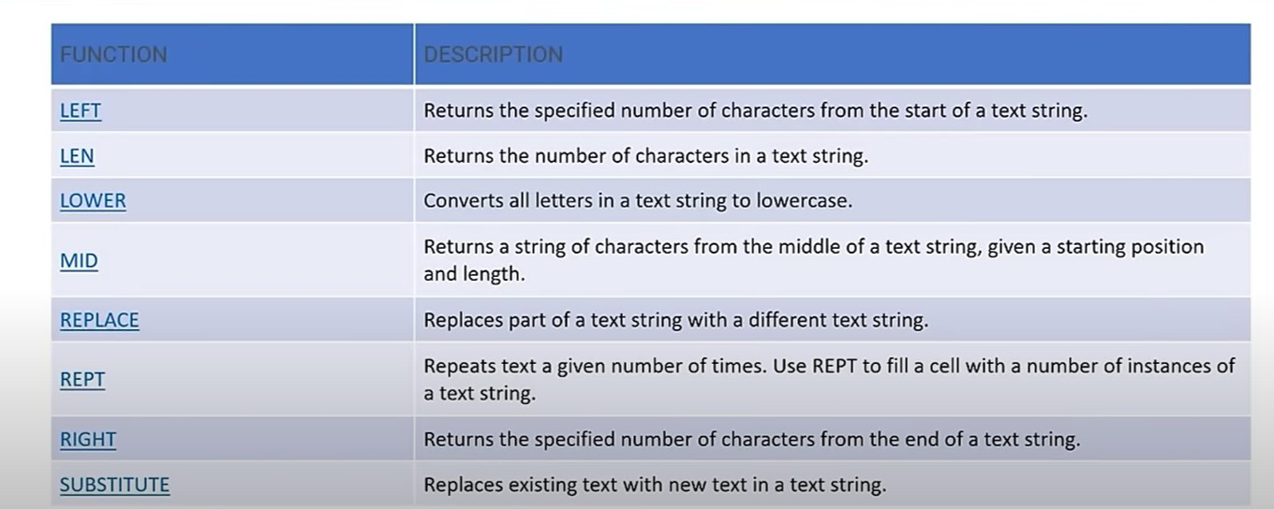

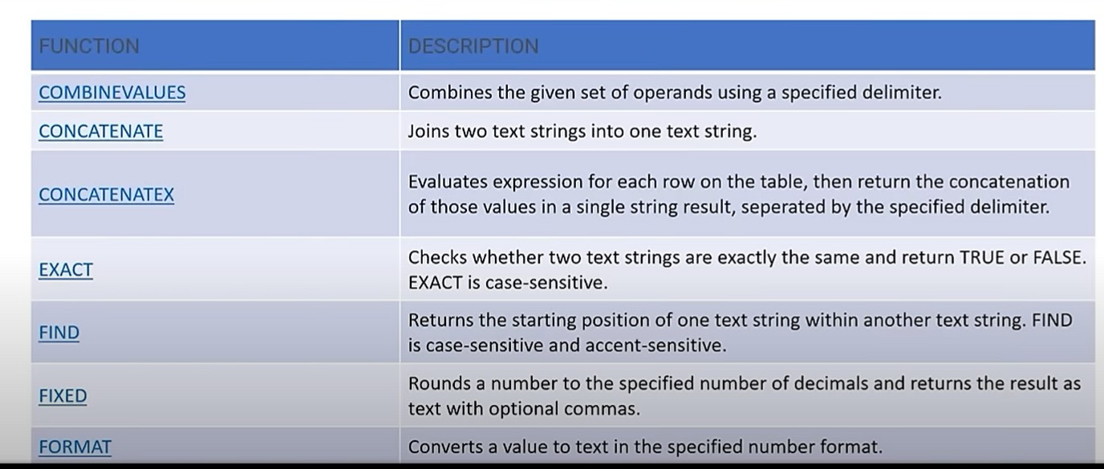
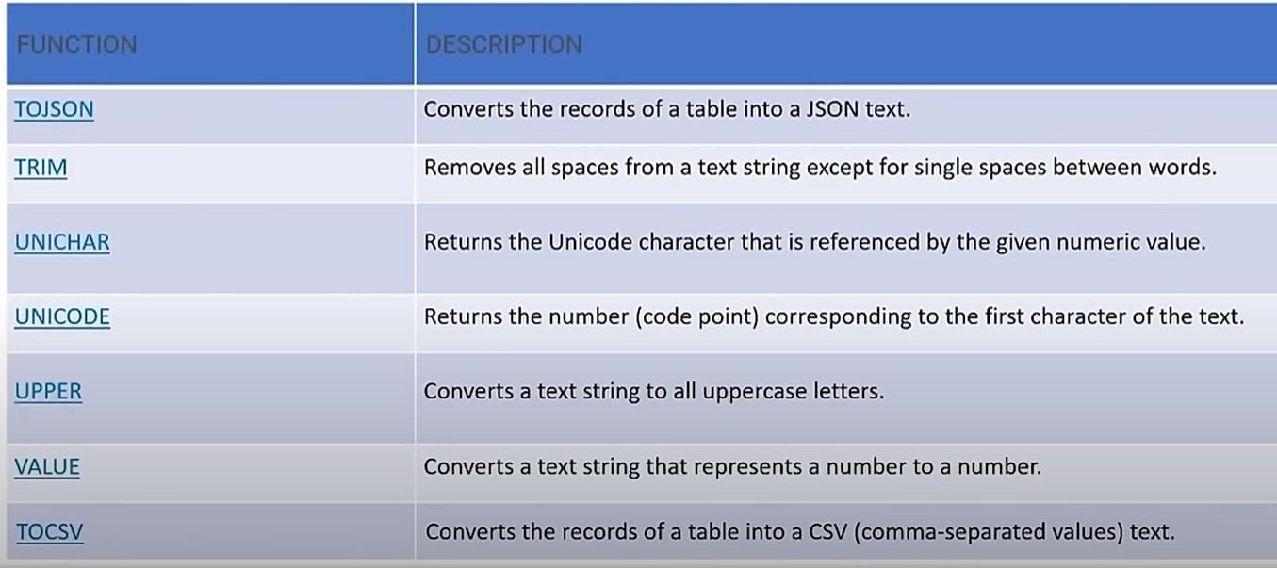

Agr r columns k data ko akatha krna ho in just one column and CONCATENATE ko use kro gy to koi delimiter nhi lga sko gy, to beheter h k COMBINEVALUES ko use kr len ta k delimiter lga sky

LOGICAL FUNCTIONS IN DAX:
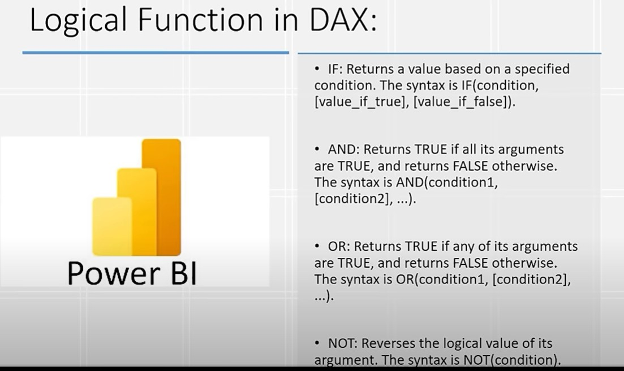
AND:
logical_condition = if(and('order details'[orderLineNumber]>10, 'order details'[quantityOrdered]>50),"ok","not")

OR:
logical_condition = if(or('order details'[orderLineNumber]>10, 'order details'[quantityOrdered]>20),"ok","not")

NOT:
logical_condition = IF(NOT('order details'[orderLineNumber]>10),"not grater than 10","greater than 10")

logical_condition = if(and('order details'[orderLineNumber]<5, not('order details'[quantityOrdered]>50)),"good","bad")

Y LAST VALI CONDITION Y BTA RHI K agr order_line_number 5 s km ho and quantity_ordered 50 s ziada na ho to GOOD show krna vrna BAD show kena h

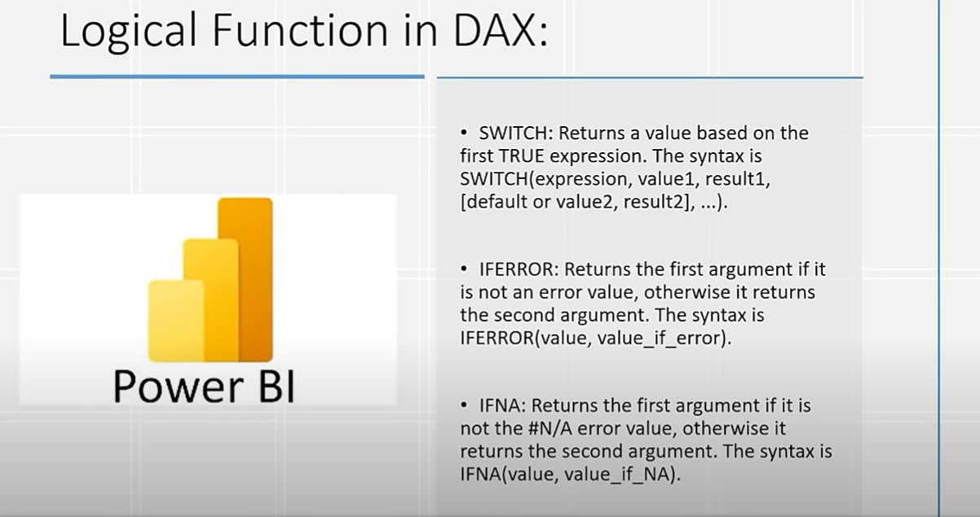

→ you can use CHATGPT for creating complex measures

TYPES OF OPERATORS:
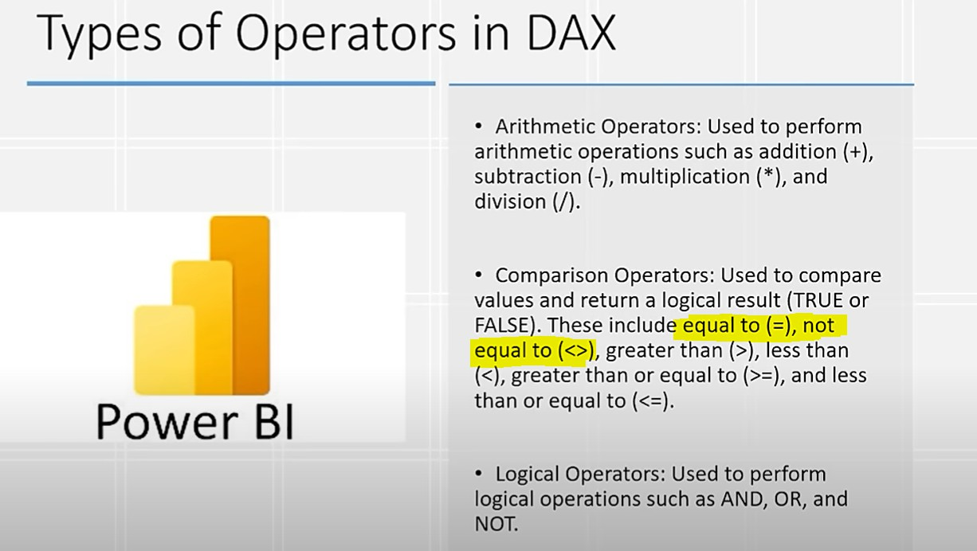

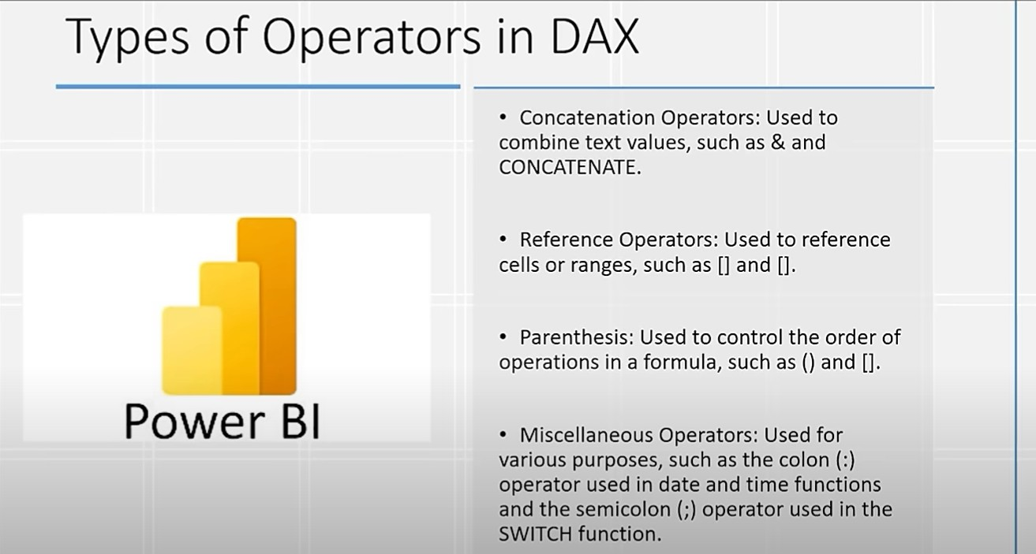
Yani ap & likho gy to bhi ap ky texts concatenate ho jay gy, just like this
Column = offices[city] & offices[country]

SUMMARIZE FUNCTIONS:
Table 2 = SUMMARIZE('products', 'products'[productName],"product_name",sum('order details'[quantityOrdered]))

Summarize is just like groupby, where you give table name (‘products’) then the column jis ki base pr group krna (‘products’[productName]) then column ka name q k hm table bna rhy to y column jo hm n dia h vo group ho ga to is new table k kis column name m jay ga which is “product_name” in this case and then value yani “product_name” valy column s jo agla column jay ga us m ho ga kia yani is product name valy column m jo names ay gy un ki values kia hon gi yani is case m vo values order_details k ander quantity order ka sum hon gi

SUM AND SUMX:
Sum is aggregate function and sumx is iterative function similarly average is aggregate function and averagex is iterative function,

MAX and MAXX:
MAX is used to get maximum value in a column and MAXX is an iterative function that is applied on tables and you want k ek specific calculation k baad table m is column s ap maximum value uthao,, e.g: ap ko highest value chahye X table m s and vo highest value kis base pr ho k isi X table k A column and B column ki hr ek ek row ki values ko multiply kro and phir jo highest value ai vo value do, to is trah y ek iterative approach hui q k isy hr ek ek row k liye multiply krna h and jo values a rhi hn un values m s highest valuemko btana h: MAXX(Sales, Sales[Quantity] * Sales[Price]) , buit MAX m hm koi expression yani koi condition nhi de skty hmy just column ka name hi dena hota k is column m s highest value bta do: MAX(Sales[Revenue])

Calculate:
calculate ek DAX function h and you can use when you want to add some filter on your data, e.g: k ap ko total sales calculate krni hn and bs saary salo m s is specific saal ki hi chahye, yani ek specific saal valic heez filter lga di
sales_2003 = CALCULATE(sum('order details'[profit]), orders[order_year]=2003)
Yani total profit ka sum calculate kro jab year 2003 ho

COMPLEX DAX EXPRESSIONS:

FIRSTNONBLANK is used to get scalar value, yani hmary pas ek hi row thi just jis m 1st column is NAME and other is Value, to is row m s hmy koi scaler value yani koi ek value leni ho to hm FIRSTNONBLANK ka use krty hn,,,
CONSIDER FOLLOWING EXPRESSION:
HighestOrderedProduct = VAR MaxQuantity =
MAXX(
SUMMARIZE(
transactions_1997_98,
transactions_1997_98[product_id],
"profit", SUM(Transactions_1997_98[profit_margin])
),
[profit]
)

RETURN
CALCULATE(
MAX(products[product_name]),
FILTER(
SUMMARIZE(
transactions_1997_98,
transactions_1997_98[product_id],
"profit", SUM(Transactions_1997_98[profit_margin])
),
[profit] = MaxQuantity
)
)
Is m y hua k hm n phly jo MaxQuantity likha h return s phly, to us m hm kia kr rhy k hm n summarize k zrye ek table draw kia jis m id and agy us specific id s milny vala poora profit_margin ka sum h and then hm n MAXX k zrye us m s maximum profit ki value utha li, e.g: vo value hmary pas
6 ai,, then hm n return m kia kia k: vhi summarize k zrye table bnaya and us table m filter kia k vo row uthao jab profit MaxQuantity k equal tha yani vo row uthao jab profit MaxQuantity yani 6 k equal tha, ab us row m s hmy product_name chahye tha to hm n MAX ka use kia to get scaler value which is product name in this case. We can also use FIRSTNONBLANK to get scaler value as well.

→ i have two tables , one is of store and other is of sales, sales table have column units sold and both tables have PRODUCT ID common, how to make that column of unit sold to store table so that i can understand what are total amount of units sold for each product? Just make a measure of “sum of units sold” and isi store valy table m ek column bnao TOTAL_UNITS_SOLD and us column ko is measure k equal kr do,, we can also do it on POWER QUERY EDITOR, jis m hm merge queries k zrye jab new column le kr ayn gy to table ko expand krty huy aggregate pr click kr k sum ko select kr den gy

→

MODULE: VISUALS IN POWER BI

Koi bhi graph daal kr graph r click kro gy to right side pr format graph k icon pr click kr k format kr skty graph ko,, you can also give LEGEND to it, legend

MEASURES:
Table view m ja kr home m new measure pr click kro to ek uper excel k formular bar ki trah ek bar show ho gi jhan hm DAX functions likh skty hn,, yhan start krty huy ap phly measure_name = formula esy likhty hn
Yani phly meaure ka name and then euakl lga kr DAX function likhty hn , and name dety huy space nhi daalni,,

agr kisi measure ka format change krna h, yani measure m currency ka symbol indian rupee s US dollar $ symbol m change krna h to usi measure kio select kr k phir chnage krna h, kisi or value ko select kr k kro gi to cards m currency ka symbol vhi purana show ho rha ho ga, card ko bhi select kr k symbol chnage nhi krna, measure ko hi select krna h table view m ja kr jab formula bar m measure ka formula change ho rha ho

→ koshish kro k measures ko usi table m bnao jis m vo data h e.g: if you wanna make measure of total sales then jis table m y sales vala column h to measure bhi usi table m bnao, otherwise us measure ko dhoondna difficult ho jata h
→ ya koshish kr lo k koi ek specific table decide kr lo jis m sab k sab measures rkhy hon

FILTERING:
Filters m ja kr product name m ja kr basic filtering m ja kr top N ko select kr k N ki value daal do and by value m vo value jay gi jis ki base pr top 10 chahye yani e.g: sales ki basis pr top 10 chahye e.g: you put N=10 to graph m top 10 values show hon gi

You can also put filter on complete page, yani y filter poory page m hr graph pr lgy , e.g: poory page m 4 graphs th , ek cities and states s related, ek highest ordered product and other 2 related to product names with profit and sales , hm n poory page valy filter m product_line ko daala and basic filtering m ja kr hm n un m s kuch kuch product lines yani product catagories select ki e.g: we selected car and bikes and trains, to ab sarry page m y jo 4 graphs th to un m

jo bhi products s related tha vo graghs bs inhi 3 catagories ki base pr hi bny ga , ab highest ordered product bhi cars, bikes and trains m s dekhy gi k kon c product sub-catagory in m s highest order hui, chahy filter k bagher highest ordered product ships m s koi hoti
Similarly: m na sirf catagory yani text valo ko daal sky bal k hm numeric valy ki base pr bhi filter lga skty poory page pr, is k liye basic ki bijay advance option m ja kr less than and equal to , greater than etc etc lgao and see the results. E.g: ap n sales ko filter valy box m daala and advance filter m daala k less than 500 and greater than 1000, to poory page m just vhi show hon gi jin ki sale 500 s ziada and 1000 s km hn
Similarly: can apply filter on all pages, if you have multiple page
dashboard

E.g: if you want k just USA k office ka hi sab show ho, to filter m country m ja kr basic filter m ja kr USA select kr do

MATRIX VISUALS:
Khi pr bhi matrix visual ko daalo and rows and columns m values put kro, this is just like pivot tables in excel. Rows m kuch column daalo and then values m us s related cheez daalo. E.g: rows m products dal di and values m sales, profit etc sab daal dia , rows m products k saath saath kuch or bhi daal skty hn jis s saath chota sa plus ka sign ay ga and us pr click kr k ap mazeed expand bhi kr skty, and you can also format that visual as well.

SLICERS:
You can add slicers which are also present in visuals and and format m ja kr settings change bhi kr skty hn, format m ja kr settings m ja kr options m ap style bhi change kar skty ho ,, format m ja kr selection m multi_select ON krny s ap ctrl ya shift k zrye slicer m s multiple values ko bhi select kr skty

Ab jab month ka slicer lgaty ho to month mostly sorted nhi hoty to ap n ek new column create krna h jis k ander DAX function lga kr date m s month number nikalna h and then month name valy column ko select kr k column tools (present on ribbon) m sort by column m month number valy column ko select kr dena h, yani btaya y ja rha h k is month name valy column ko is month number valy column ki base pr sort krna h and then slicer m sorted show hony lgy gy

Jesy excel m report connections hota tha vesy hi yhan edit interactions h, slicer ko pick kro and ribbon k format m ja kr edit interactions pr click kro and

jis graph ko disable krna h us graph k top right side pr ek esa 🚫 black n white symbol ho ga us ko select kr dena and dubara us edit interaction valy button pr click krna ta k vo button deselect ho jay,,,, and if you want k ap n us graph r edit interaction k zrye slicer ka interaction hta dia and you want to again interact that chart with the slicer interaction to again click on slicer and click on edit interaction then jis graph pr interaction dubara lgaya h to us graph ki top right side pr 🚫 is symbol k saath ek symbol ho ga FILTER vala us ko select kr do and dubara edit interaction pr ja kr us ko click kr do ta k deselect ho jay

BLANK VALUES ON SLICER: if slicer is having blank value and you don’t want to show blank value over it, then filter m ja kr “is not blank” ko select kro

Cards:
Mostly we put measures in cards, measures create nhi bhi kia hu and just sum etc ko calculate krna h to just card ko put kro and card k data m vo column daal do to sum automatically ho kr a jay ga, isi data vali drop down m click kro and sum ki bijay kuch bhi daal skty ho,, similarly multi_row cards bhi daaly ja skty hn , and yhan bhi ap don’t summarize ki bijay sum, average etc kuch bhi daal skty ho,,,

→ click on slicer new to show all measures in one card in a very good way and to change label of all cards one by ione, such as to change “sum of total cost” to “total cost” then click on CALLOUT VALUES and us card ki value ko select kro jis ko change krna h and neechy scroll krty jao and label m ja kr text ko chnage kr do ,,,, and to show all cards in a single line: go to layout and increase kr do number

KPI CARDS:
They are used when you have to show k pichly saal itni sales thi and is saal itni hn, yani pichli value s compare krny k liye
→ is k liye ap ko measures create krny hn phly 2003 k liye then 2004 k liye and then KPI cards m value m 2003 daal dena and target m 2004 q k hm y dekh rhy k 2004 ka pichly saal s kia change h , agr hm 2003 ka dekhna chahty hn k agly saal s kia difference h values m to target m 2003 daal do, and trend axis m months daal do q k hmy per month dekhna h trend, agr color green show ho rha to yani target valy ka pichly vali value s ziada value h and agr red show hua to yani target vali value pichli value s buri h yani km h, and ap format m ja kr trend axis m ja kr colors change bhi kr skty ho,, agr values ko K

ya M yani kilo ya millions m show krvana h to callout value m ja kr change kr skty hn

MAP VISUALS:
Chart m map valy chart ko daal kr ap location vise graph bna skty ho, location valy portion m koi location daal do,e.g: m n customer ki cities daal di and format m ja kr settings m ja kr zoom buttons ko ON kr do to zoom buttons s ap zoom bhi kr sko gy k kis region m ziada customer ay and neechy bubble size m ja kr count of customer ID daalo to is s jo bubble ziada bra ho ga to yani is region m ziada customers ay hn,, and of course ap city k ilava koi ior location bhi daal skty such as country

LASSO button ko ON krny s ap k pas graph pr jo button show ho ga us pr click krny s + k nishan ay ga yani ap ek rectangle select kr skty graph m k ab mujy isi region s related sara data chhaye to poory dashboard m sab usi region k according show ho ga, and graph pr right click kr k clear selection pr click krny s graph vapis saary regions k according hi show hony lgy ga

You can also use filled map, jhan jo jo cities ya countries match hon gi, vo poori poori filled ho gi kisi color s and of course you can change color as well, E.g: agr rassia m chahy ek hi customer ho but still poora russai filled nazar ay ga

TREE MAP:
Categories and us s related values k liye, you can also add data labels jis s hover krny pr kuch nhi show ho ga alag s q k data us categories s related values uper hi show rhi hn

TOOL TIP:
Ab ap n ek graph bnaya hua h, le’s say year vs profit ka and us ki bars pr hover krny s ap ko cards show ho rhy hoty hn, but ap chahty ho k jab bars pr hover kry to poora graph show ho jo k us specific bar yani us specific year pr hr category ya sub-catagory ki sales btay, to it is possible using tooltip,

→ All you have to do is to create a new page and and us m page format m ja kr canvas settings m ja type m tooltip ko select kr dena h, is s page ka size chota ho jay ga and and ek graph bnana h (koi bhi graph bna lo jo ap chahty ho k bars ko hover krny pr show ho) is case m m catagory and profit k drmian bna rhi and us graph ka size poory page k size k equal rkhna h, and then usi bar graph pr vapis ana h and format m ja kr general m ja kr header icons m ja

kr tooltip m ja kr page m us page ko select krna h jis page m ap n poora single graph bnaya hua h (itni scrolling ki zrort nhi vesy, just format m ja kr search kr lo PAGE ko and you will get option ko select that page),, is trah hover krny pr poora new graph show ho ga

→ and y ap bar graph k ilva kisi k saath bhi kr skty ho DASHBOARD STYLING:
→ kisi bhi card ko pkro and format m border search kro and border ON kr do , which looks good
→ ek card ko sja do and usi card ko pick kr k home m ja kr format painter ko click kro then cursor paint ki shape m ho jay ga and doosry card k uper us ko click kr do then doosry card ka bhi same format ho jay ga jo phly valy ka h , you can do it for graphs as well.

BUTTONS AND BOOKMARKS:
Insert m ja kr buttons hn, koi bhi select k lo, e.g: i selected back button and hm chahty hn k us button or click ho to kisi doosry page pr navigate ho jay, to is k liye button ko click kro and action m ja kr type m page navigation select kro and destination m us page ka name daal do jis pr ap chaty ho k button click hony pr hm phunchy, e.g: this is mostly used when you have dashboards on more than one page and on clicking button you navigate to the previous page

BOOKMARKS: ap n koi graph bnaya hua h and us k uper chota sa bookmark ka icon lga dia and us pr jab ap click kro gy to ek page open ho ga jis pr detailed information ho gi us graph k baary m , yani agr koi graph tha country vs sales and usi pr hi bookmark lga ho and jesy hi ap us prclick kro to page open ho jis m 4 s 5 us s related graphs ho e.g: city vs sales, city vs profit, country vs profit etc etc,,, to bookmark k liye is page pr detailed information ho gi ya jis page ko ap chaty ho k jab graph pr click ho to y page show ho, to us page yani us detailed information valy page m view m ja kr bookmark pr click krna h and jo side pr book ark vala show ho ga us m add or click krna h and bookmark ka koi bhi name de do, let’s say “detailed view”, then ap n us dashboard valy page pr jana h and bookmark ka symbol daal kr jo k vhi buttons m hi mily ga and us symbol k action m type bookmark select kr k and destination m none ki jga detailed view select krna h

Zruri nhi k just buttons and bookmarks hi ho , ap images pr bhi action lga skty

→ IF YOU WANT K EK MOTA SA COLUMN TYPE KUCH BNA HO JIS PR
SAARY SLICERS HON (like in health care analysis dashbaord) and koi button click hony pr vo filter vala section show ho ,, so you will make 2 buttons, one contains “OPEN FILTER” and other contains “CLOSE FILTER” and us dono buttons ko exact ek doosry k uer rkh kr selection m ja kr group kr do , then isi selection m ab 2 groups hm hmary pas (ek buttons vala and ek slicers vala , yani vo mota sa column jis pr saary slicers hn, [saary slicers and vo mota column bhi grouped hn ]), SO, select both groups and close vay ko hide kr do by clicking eye icon then FILTERS m ja kr filter add kro and filter name will be “OPEN” then click on 3 dots (isi “OPEN” k agy jo lgy hn) then uncheck DATA, uncheck CURRENT PAGE and check SELECTED VISUAL and then click on UPDATE (yhi pr hi y option bhi ay ga) then hide CLOSE and SLICER vala group and ctrl dba kr dono groups ko select kro and add bookmark named close then uncheck DATA , CURRENT PAGE and check SELECTED VISUAL and click on update

AI VISUALS:

DECOMPOSITION TREE:
Used for analysis jis m hm hierarchical type structure btaty hn, e.g: hm chahty k sales ka analysis kryn then next hm btayn k kin products s vo sales ai and total kitni ai, then is saal m in products pr kitni sales ai and next saal m kitni ai.,,,
analysis m vo data enter kro jis ka poora graph bnana chahty, yani hmy “sales” s related chahye to hm ANALYZE valy m sales likhyn gy and agy kis ki base pr chahye yani products ki base pr to explain by m PRODUCTS daalyn gy and agy hmy mazeed year chahye to isi m hi year vala column bhi drag and drop kryn gy, jesy hi daaly gy to + k sign pr click kr k btayn gy k hmy higher value s start krna h show krvana ya lower s

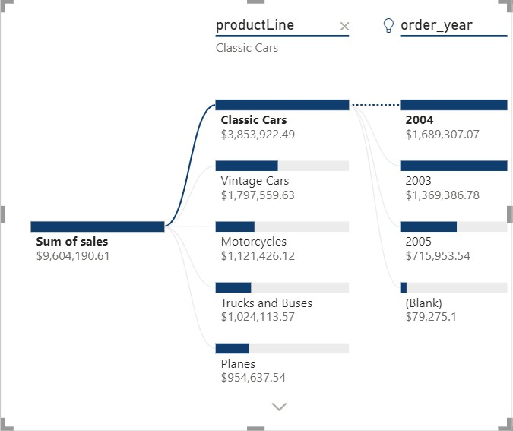
Yani total sales $9604,190 thi and in m classic cars s total sales $3,853,922 ai and in classic cars m 2004 m itni sales ai, 2005 m itni ai, jitni shown h picture m,,,,,, yani hm decompose kr rhy total sales ko, that’s why it is called decomposition tree

Ab second decomposition jo k years ki base pr h vo just classic cars ki show ho rhi, baqio ki nhi ho rhi to is k liye click on bars, vintage Car vali bar pr click kro to usi ki show ho gi

KEY INFLUENCERS:

Q AND A:
as it is AI based to Is m ap koi bhi question likhty ho to ap ko answer milta h, e.g: ap chaty ho k total count of products to ap y likho k what are total number of products and you will get answer ,,, and this is amazing, y bbhhhhttt achy achy answers bhi deta h

SMALL NARATIVE:
Kisi graphg ko pick kro jis ka a chaty ho k ek narative likha hua ay, yani us graph s miltny valy analysis ko text paragraph ki form m likha hua mily,, to select that graph and pick small narrative from AI visuals,, then ctrl Z kr k vpios chart hi show kr do, but this is amazing ,, to kbhi report prepare krni ho to use AI narative to show text data and can use that data as well.

→ there is also another AI feature in POWER BI, not in category of AI visual graphs. Make a line chart and make sure that x_axis has dates over it, agr ap n dates ko x_axis m daala to of course ap graph k uper down arrows pr click kr k move kr sky among days, months, quarter etc, but yhan koshish kryn k just dates hi hon, then format k saath valy button “ADD FURTHUR ANALYSIS TO YOUR VISUAL” m add anomalies ko ON kr do, is s ap k graph m jo jo anamolies ai vhan pr bubbles bn jay gy, bubbles ko hover krny pr btay ga k ap ki expected itni thi is date pr and expected min and m,ax itna tha but itna
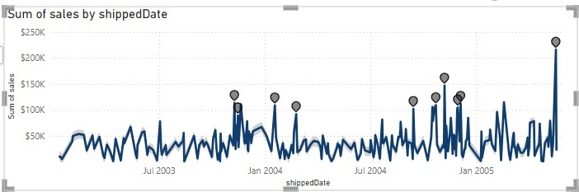
aya to y ek anamoly hui,,,, agr hm n y sales and date k drmian bnaya h to may be that day sales is lye increase hui k koi occasion rha etc

MOBILE VIEW:
Dashboard ko ap mobile view m bhi show krva skty ho and for that dashboard ki file m rehty huy go to view and select mobile view and saary KPIs, cards, slicers etc ko arrange kr do

NEW PARAMETERS:
Line chart m ap chaty ho k kuch esy show ho:
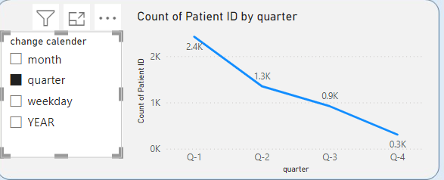 yani graph k saath alg s ek slicer tyoe bna ho jo k graph ko change kry, for this: select this graph , go to modeling then to add parameter then to field then write parameter name which is “chnage calender” in this case and then jin jin ko add krna un un ko click kr do , i added month, quarter, weekday and year then

click OK then is line graph k x-axis m ja kr isi “chnage calender” valy table ko add krna h and tan tna 😀

CONDITIONAL FORMATTING:
E.g: hm n TABLE VISUAL bnaya and hm chahty hn k jesy excel m rows/bars ka color aya tha is trah s ya to lowest value pr poori row ka koi color change hua tha and highest value pr koi or color aya and ya to bar m highest value pr poori bar pr color aya and lowest value pr us s thori bar colodful hui,, similarly hm yhan bhi kr skty, just make table visual, e.g: we make table between products and price, ab hm chahty k jo price ki value sab s ziada hui us pr red color a jay and jio value km h us pr green color a jay, to right click on price (in column in build visual) and select CONDITIONAL FORMATTING, and is m background color m jao, vhan bhhtt s options hn,, if you select count to green color us value pr ay ga jo bhhtt bar repeat hui and red color us or ay ga jo bhhtt km repeat hui, ab yhan price to hr ek ki different h to sab ka ke hi color ay ga, is liye better to use MIN here.

→ similarly, we can also add data bars here,
→ similarly, RULES ko select kr k if-else condition bhi daal skty

GROUPS AND BINS:
GROUP IS FOR TEXTUAL DATA AND BINS IS FOR NUMERICAL AND TEXTUAL DATA BOTH,, WE CAN ALSO PUT BINS ON DATES AS WELL.

GROUP: e.g: if you have a dataset in which different columns such as product_names, ids, product_price and store_names etc are avzatailable. You want to make lists such as ek list ho jis m un stores k name ho jo achy hn and ek m un stores m names hon jo bury stores hn , to is store valy column pr right click krna h and NEW GROUP pr click krna h and ctrl dba kr un un stores pr select krna h jo ap ek list m daalna chahty ho and kuch ko select kr do jinhy ap doosri list m daalna chahty ho and click GROUP and GROUPS AND MEMBERS m vo names jab a gay to us list ka name rename bhi kr skty

BINS:
BIN SIZE: yani ek bin m kitni values ay gi

BIN COUNT: yani total kitny bins m data ko divide krna h

→ e.g: mery pas age ka column tha jis m values random thi yani 78, 12,65,76,43,87,54,21,58,97 etc, jab visualization kryn gy to achy s show nhi ho ga, hm in ko bins m convert kryn gy , let’s say we put bin size = 10 to ten ten values k bins bny gy yani if value ranges from 10 to 20 to column m jo value ay gi vo 10 ay gi,

→ you can also put BINS on dates as well, e.g: if we put bins on date like 1 JAN 2022 and so on, then e.g: bin size m 8 rkha and agy months select kia to is ka matlab y hua k 8 months ek bin m ayn gy and us ki value January vali ho gi if these months start from January to August, yani phly eight months from January to august sab ek bin m ay gy and jo new column bny ga us column m in 8 eight months vali date m agy January hi likha ho ga and then agly 8 months from september to april (april of next year) next bin m ay gy and in ki value new column m Febrary nhi ho gi unless you define that in a custom column,,,,,, that’s why for months we put bin size as 1 ta k ek hi month ek bin m ay yani agr dates 1 jan s 30 jan tak hn to un sab dates k agy january hi ay

HOW TO GET MINIMUM ORDER DATE PER CUSTOMER?
→ yani y check krna k y customer new h ya repeating h to hm y dekhy gy k is specific customer n jitni bar order kia to un sab orders m s minimum order date kia h and then hm dubara ek new column bnay gy jis m dekhy gy k agr hr row m s k is customer id pr jo ab order date mention h kia vo vhi order date h jo hmy mimumum order date valy column m mili h , agr yes to yani vo customer new h vrna vo customer repeating h

min_order_date =
calculate(min(Transactions_1997_98[transaction_date]),ALLEXCEPT(Transactions_1997_9 8,Transactions_1997_98[customer_id]))

customer_type =
if(Transactions_1997_98[stock_date]=Transactions_1997_98[1st_order_date],"new customer","repeated customer")

THE MOST EASY WAY TO CREATE CARDS:
If you want to create high ordered product, to ek visual table bnao jis m sum saary orders daal do, then usi table m hi product_name/id ko bhi drag and drop kr do then filters m ja kr top 1 select kr do, then table visual m s hi sum of

saary orders vala column remove kr do, is trah table visual m just name a jay ga product ka then isi table ko select kr k convert kr do card m

HOW TO ET AVERAGE BILLING AMOUNT PER VISIT WHEN WE HAVE PATINET ID COLUMN AND TOTAL BILLING COLUMN?

average_billing_amount_per_visit = sum(visits[billing amount])/DISTINCTCOUNT(visits[Patient ID])

E.g: 700 patients s 500$ amount bni to ek patient s 500$/700

→ TEXT BOXES ki bijay you can use: Go to buttons and select blank one and shape m ja kr ap shape bhi select kr skty, and style m ja kr text ko ON krny s ap isi rectangle k ander text bhi link skty and style m ja kr ON HOVER select kr lo ya koi bhi select kr lo and then ap is ka fomt etc change kr di ya c and font colour dono change kr do jis s hover krny pr vo effect show ho ga

HOW TO INSERT IMAGES AS SLICER?
LIKE IN HEALTH CARE ANALYSIS DASHBOARD, jhan doctors ki pictures dali hui h, put slicer new vhan pr FIELD poora names vala column daal do q k hm chahty hn k images k neechy names bhi likhy ho and then isi format m hi images m ja kr image URL vala column daal do, agr urls pr images ni hn bl k ap k system k ander hn to system vali image sko kisi jga upload kro, and is ki YT s koi video dekh lo

HOW TO MAKE I click button "OPEN" and a small widow open above the same page where all slicers appear then we select a slicer and then we click on button "CLOSE" and slicer window disappear?

Steps to Create the Pop-up Slicer Window:

- Create the Slicers:
  - Place your slicers on the report page where you want them to appear when the pop-up window is shown.

  - Make sure these slicers are in the location where you want them to pop up.

Create a Shape for the Pop-up Background:
  - Go to Insert > Shapes and insert a rectangle or any other shape.
  - Place this shape behind the slicers to act as the pop-up window background.
  - Format this shape (e.g., set transparency, color) to make it look like a pop-up window.

Group the Slicers and Background:
  - Select the slicers and the shape (pop-up background) by holding down CTRL and clicking them.
  - Right-click and Group them. This will make it easier to manage
as a single unit.

Create Bookmarks:
  - Bookmark 1 (Hidden State):
    - Go to the Selection Pane (found under View > Selection).
    - Hide the slicer group by clicking on the eye icon next to the group.
    - Once the slicer group is hidden, create a bookmark (go to View > Bookmarks and click Add). Name it something like "Slicers Hidden".

Bookmark 2 (Visible State):
    - Now, show the slicer group by clicking on the eye icon in the Selection Pane.
    - Create another bookmark (with the slicers visible) and name it something like "Slicers Visible".

Create the Buttons:
  - Go to Insert > Buttons and insert two buttons:
    - Button 1 (OPEN): This button will show the slicer pop-up.
    - Button 2 (CLOSE): This button will hide the slicer pop-up.

Assign Bookmarks to Buttons:

  - Open Button:
    - Select the "OPEN" button.
    - Go to the Format Pane and expand the Action section.
    - Turn on Action, and under Type, select Bookmark.
    - Choose the "Slicers Visible" bookmark (to show the slicers when the button is clicked).

Close Button:
    - Select the "CLOSE" button (which should be placed on the pop-up window itself).
    - Turn on Action and set it to Bookmark.
    - Choose the "Slicers Hidden" bookmark (to hide the slicers when the button is clicked).

Test the Buttons:
  - Click the "OPEN" button, and the slicers should appear in a small window (pop-up style).
  - Click the "CLOSE" button, and the pop-up slicer window should disappear.
→ MAKING LONG STORY SHORT: ek baar selection m ja rk slicer window ko hide kr k bookmark create kro “slicer hidden” and ek baar unhide kr k bookmark create kro “slicer visible” then OPEN FILTER valy button pr click kr k ACTION “ON” kr k TYPE bookmark select kr k and BOOKMARK m SLICER VISIBLE ko select kr do and then CLOSE FILTER button m bhi action ON kr k book ark select kr k SLIDER HIDDEN select kr do

